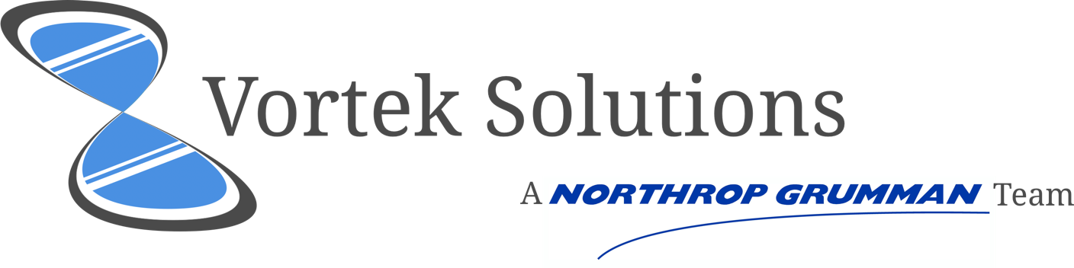

JAD2 Meeting Agenda

Members:

Justin Goulet, Chris Larsen, Mikal Callahan, Brock Corbett

# JAD 2 Meeting Agenda

## Roll Call

|  |  |
| --- | --- |
| Member Name | Is Present |
| Justin Goulet |  |
| Christopher Larsen |  |
| Mikal Callahan |  |
| Brock Corbett |  |
| Dr. Shauninn-Wu |  |
| Thomas (Ty) Usrey |  |

|  |  |
| --- | --- |
| Meeting Start | Meeting Adjournment |
| 3:30 est. |  |

## Topics of Discussion:

|  |  |
| --- | --- |
| Outstanding Issues: | Research Presentation  Summary of Phase 1  Finalize Object Requirements & Definitions  Design Outline Approval / Questions |

|  |  |
| --- | --- |
| New Agenda Items |  |
| Justin Goulet | **Goals:** What specific tasks are you expected to have completed in our first prototype phase?  **Requirements Review:** Review updated information provided via Slack yesterday. |
| Chris Larsen | **Object Definition:** Review attached page an ensure consistencies.  **Project Deliverables:** What is required by our next meeting per the client’s project requirements? |
| Mikal Callahan | **Design Outline:** Demonstrate top-level hierarchy of widget (design before additional information was provided) |
| Brock Corbett | **Project Technologies:** Review list of proposed solutions – D3 is prominent possibility (List will be provided in meeting).  **Feasibility:** Discuss how technology can provide solution. |

# Workflow Object Definition

1. Workflow object will have following attributes:
   1. Initiator
   2. Assignee
   3. Start date
   4. Expected end date
   5. ID
   6. Type
   7. Description
   8. Percent complete
   9. Users will permissions
   10. Expected states for workflow
   11. Additional “state flows”
2. Widget will expect a base object that contains the workflow info and possible workflow states:
   1. Minimum required info for a successful render:
      1. Initiator
      2. Assignee
      3. In this case workflow, will default to:
         1. Type: simple
         2. Number of states: 3
            1. Initiated
            2. WIP
            3. Completed/archived
         3. Start date: date/ time of request submission
3. Workflow object will also be able to render other “state flows”
   1. These will be other hierarchical relationships
   2. Ex. Product based workflow
   3. Alternative state flows can be sent with initial request or added later
      1. Need to determine if states will be stored in widget or passed in
   4. Data needed for new alternative state flow(s):
      1. ID
      2. Name
      3. Description
      4. “Children nodes”
         1. Objects that inherit from root object
   5. State flows can then be saved for use in other workflows